Composer CLI

💻 What Is Composer CLI?
# Source: AI Source: Provided by: [Data Path: Persons Table -> ID Column: 1, Name_En Column: Motasem Essam] -> From: [Chatgpt (GPT‑5 Mini)] on [1/26/2026]
Composer CLI (Command Line Interface) is the tool you use to run Composer commands in your terminal or command prompt to manage PHP dependencies, autoloading, packages, and scripts.
Think of it as the control center for your PHP project setup.

🧰 Composer CLI Is Used For:
# Source: AI Source: Provided by: [Data Path: Persons Table -> ID Column: 1, Name_En Column: Motasem Essam] -> From: [Chatgpt (GPT‑5 Mini)] on [1/26/2026]
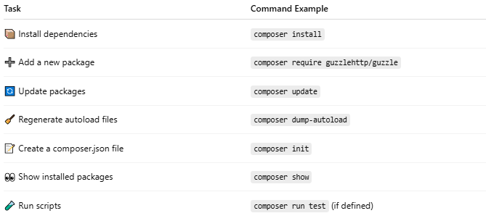

Task | Command Example
📦 Install dependencies | composer install
➕ Add a new package | composer require guzzlehttp/guzzle
🔄 Update packages | composer update
🧹 Regenerate autoload files | composer dump-autoload
📝 Create a composer.json file | composer init
👀 Show installed packages | composer show
🧪 Run scripts | composer run test (if defined)

🔧 Common Composer CLI Commands
# Source: AI Source: Provided by: [Data Path: Persons Table -> ID Column: 1, Name_En Column: Motasem Essam] -> From: [Chatgpt (GPT‑5 Mini)] on [1/26/2026]
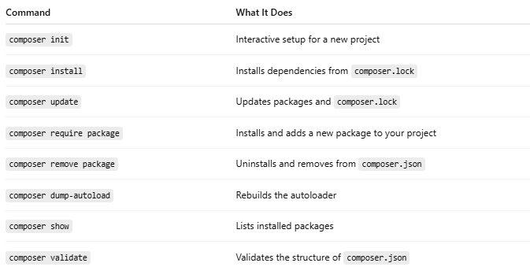

Command | What It Does
composer init | Interactive setup for a new project
composer install | Installs dependencies from composer.lock
composer update | Updates packages and composer.lock
composer require package | Installs and adds a new package to your project
composer remove package | Uninstalls and removes from composer.json
composer dump-autoload | Rebuilds the autoloader
composer show | Lists installed packages
composer validate | Validates the structure of composer.json

🖥️ How to Use It
# Source: AI Source: Provided by: [Data Path: Persons Table -> ID Column: 1, Name_En Column: Motasem Essam] -> From: [Chatgpt (GPT‑5 Mini)] on [1/26/2026]
- Open Terminal (or CMD)
- Go to your project folder:
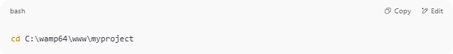
cd C:\wamp64\www\myproject

- Run any Composer command:
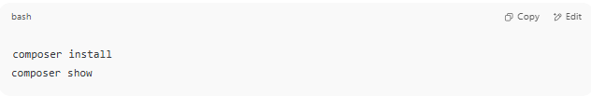
composer install
composer show

If you see this:
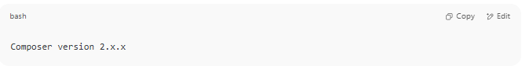
Composer version 2.x.x

Then it's working properly ✅

📦 Example Workflow with Composer CLI
# Source: AI Source: Provided by: [Data Path: Persons Table -> ID Column: 1, Name_En Column: Motasem Essam] -> From: [Chatgpt (GPT‑5 Mini)] on [1/26/2026]
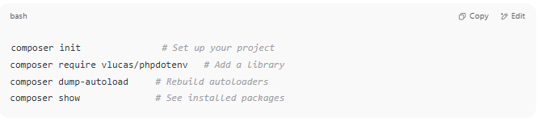
composer init # Set up your project
composer require vlucas/phpdotenv # Add a library
composer dump-autoload # Rebuild autoloaders
composer show # See installed packages

✅ Summary
# Source: AI Source: Provided by: [Data Path: Persons Table -> ID Column: 1, Name_En Column: Motasem Essam] -> From: [Chatgpt (GPT‑5 Mini)] on [1/26/2026]
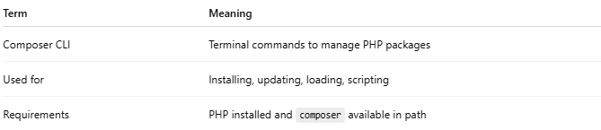

Term | Meaning
Composer CLI | Terminal commands to manage PHP packages
Used for | Installing, updating, loading, scripting
Requirements | PHP installed and composer available in path

